# Long USDCNH and Short USDCLP

## Thesis: Persisting inflationary pressures in Chile will warrant aggressive rate hikes in the near future, while greater economic issues in China will push a more accommodative monetary policy, including further rate cuts. Additionally, EM-related outflows in China will likely be more significant than those in Chile.

## Chilean inflation, hikes

Chilean inflation has continued accelerating in Jan at the monthly rate of 1.2%, more than double analyst estimates of 0.5% for the month. Annual inflation rose for the 11th consecutive month, to 7.7%. The increase in inflation came after a historic rate hike in Jan of 150bps and 500bps hikes since July, neither of which have been able to halt persistently rising inflation (Appendix A). Inflation has been driven by imbalanced consumption recovery, commodity-price (oil, food) inflation, and de-anchoring expectations.

Inflationary pressures can be expected to continue on the back of increasing global commodity prices, aligning with regional trends. De-anchoring inflation expectations will likely also persist without monetary tightening and signs of inflation reversal towards the CB’s 3% target. These combined effects will warrant significant hikes in the coming months. The market has recently begun pricing in aggressive hikes (Appendix B), though they are not excessive given the inflationary outlook.

**Further chinese rate cuts, outflows**

China’s robust growth in the 2000s was driven by large state-directed investments and supply-side stimulus to domestic infrastructure, which in turn shored up large amounts of credit. While returns on initial investments proved enough to recoup borrowing costs, these windfalls have diminished over time leading to ballooning debts that were jeopardised by the pandemic. Consumer demand has yet to recover and as such China faces a disinflationary situation with inflation less than 1% YoY according to latest figures. So, further monetary and fiscal stimulus will be needed to compensate for bad debts, weakened loaning, and subpar consumer demand recovery. This could include monetary expansion and further rate cuts than the ones implied by the market (Appendix C). Additionally, we are likely to see intensified outflows due to the concurrent Fed hiking cycle and changing relative yields. When compared to expected Chilean outflows, Chinese ones will be more significant for stated reasons.

## Trade risks, copper

Recently, the outgoing Chilean Finance Minister noted that terms of trade risks remain elevated, supported by the Ukrainian conflict. Petroleum and other energy products are the largest imported commodities and, while there continue to be upside risks related to shortages, it is unlikely that prices will rise much further, with increasing OPEC+ production and output and the recent spike due to Ukraine-Russia concerns.

On the other hand, copper and copper-related products account for almost 50% of exports. Chilean copper output declined over the past year chiefly due to decreasing demand from China, Chile’s primary trading partner, though significantly increased prices compensated for lost volume. Price increases have stalled, however, due to this drop in Chinese demand. While I do not expect Chinese demand recovery in the short-term, the risk to Chile of continued weak Chinese demand is hedged by our short yuan position.

Escalation in the Ukraine situation poses limited upside risks to copper prices. Copper has additional support from the longer-term supercycle as countries transition to copper-intensive carbon-neutral energy, cars, and infrastructure. Many copper projects have fallen behind due to COVID-19 and, according to Goldman Sachs, peak copper production is approaching rapidly. Given the lag in pandemic-era investments but intensification of supercycle demand as global consumption recovers, I expect that copper prices will at least remain stable in the near-term. Thus terms of trade risks for CLP remain limited.

## Chilean political risk

Widespread protests and unrest in 2019 were followed by internal violence in an indigenous region. Amid a wave of left-leaning LatAm victories, a leftist reformist Gabriel Boric won the presidency and a Constitutional Convention, consisting of largely left-leaning delegates, was tasked with rewriting the current constitution.

Gabriel Boric, while being a leftist reformist, faces a congress split between left and right, so his radical policies will likely have to moderate in order to pass. Once he assumes the presidency next month, if a more moderate form of these policies are proposed, they will actually aid the country’s social stability and fiscal development, with positive impacts on its economic strength.

While some of the Constitutional Convention’s proposals – such as a recent nearly-passed article giving indigenous people a veto over economic developments in their ancestral land – have spooked the market, these sorts of policies are not representative of the conventions’ ideological stance. Indeed, the constitution that emerges out of the delegation will still need to be voted upon by the public in Q3 for approval. Polls have indicated that, amid controversies, support for the new constitution has already declined to below 50%.

## Conclusion

## Political risks in Chile seem to be largely overblown and the recently-cited risks to the Chilean terms of trade appear minimal. Chilean inflation will persist at an elevated level, demanding more aggressive hikes from the BCC. The prospect for Chilean economic growth remains strong. On the other hand, China faces a weak economic situation that demands intensifying monetary and fiscal policy support from the PBOC and the central government. This will include more rate cuts and intensify its outflows relative to Chile’s.

**Appendix**

1. Chilean inflation, policy rate

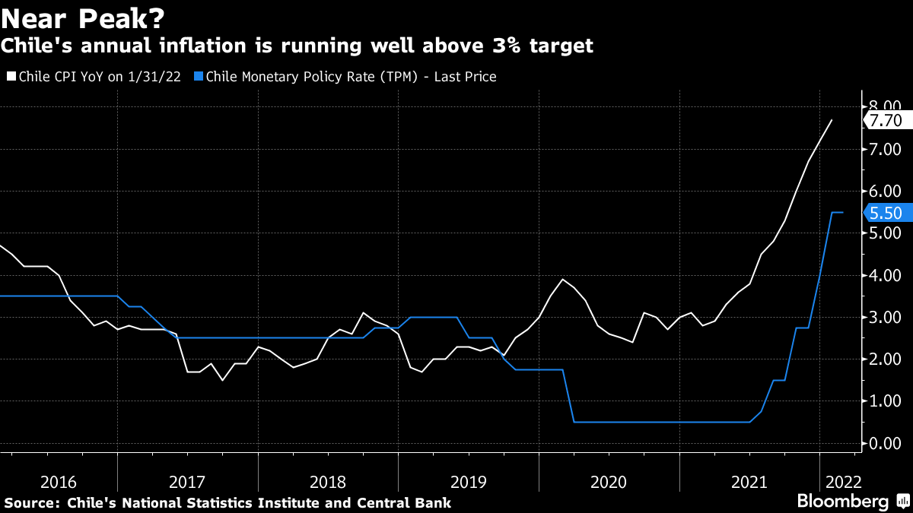

1. Chilean MIPR

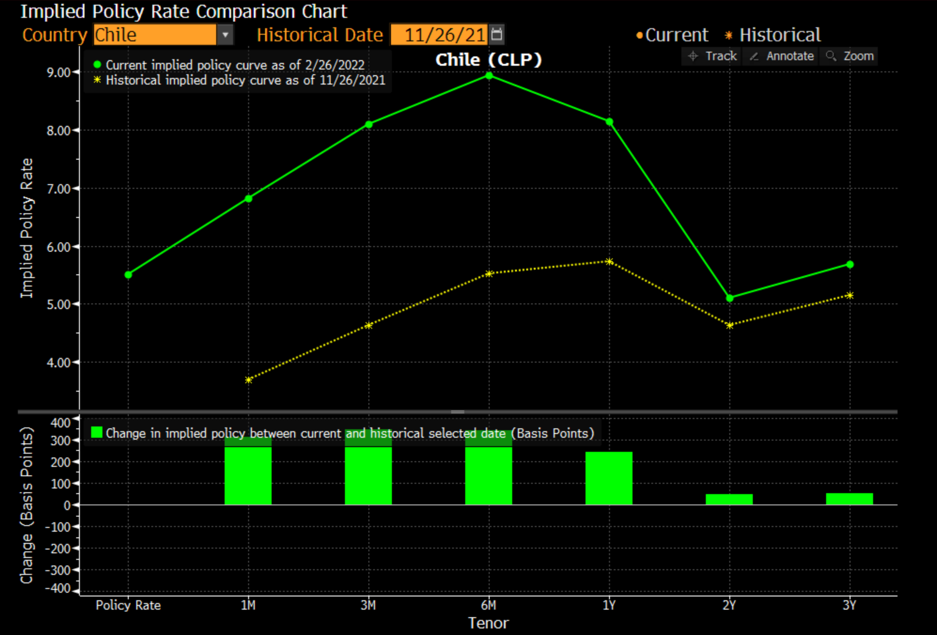

1. Chinese MIPR 